

# Practices for Secure Software Report

Table of Contents

Document Revision History 3

Client 3

Instructions 3

Developer 4

1. Algorithm Cipher 4

2. Certificate Generation 4

3. Deploy Cipher 4

4. Secure Communications 4

5. Secondary Testing 4

6. Functional Testing 4

7. Summary 4

8. Industry Standard Best Practices 4

## Document Revision History

| **Version** | **Date** | **Author** | **Comments** |
| --- | --- | --- | --- |
| **1.0** | **[Date]** | **[Your Name]** |  |

## Client



## Instructions

Submit this completed practices for secure software report. Replace the bracketed text with the relevant information. You must document your process for writing secure communications and refactoring code that complies with software security testing protocols.

* Respond to the steps outlined below and include your findings.
* Respond using your own words. You may also choose to include images or supporting materials. If you include them, make certain to insert them in all the relevant locations in the document.
* Refer to the Project Two Guidelines and Rubric for more detailed instructions about each section of the template.

## Developer

[Insert your name here.]

## Algorithm Cipher

Artemis Financial requires a strong encryption method to address security vulnerabilities. A recommended solution is the Advanced Encryption Standard in Galois/Counter Mode (AES GCM). AES GCM provides confidentiality by keeping data private and integrity by generating an authentication tag that verifies data has not been altered. Using a 256-bit key (AES 256 GCM) ensures a high level of security. AES was standardized by NIST in 2001 and is widely used in the industry, making it suitable for Java-based applications.

It is recommended to use a trusted random number generator, such as Java’s SecureRandom, to create unique keys and initialization vectors (IVs). Each encryption operation should use a new, unpredictable IV to prevent weakening security. For secure key exchange, asymmetric algorithms such as RSA with OAEP padding or Elliptic Curve Diffie-Hellman are recommended. These approaches allow systems to share secret keys without exposing them to attackers. Proper key storage and handling is also recommended to maintain the integrity of encryption.

Strong hash functions such as SHA-256 or SHA-512 are recommended to verify that data has not been altered. Hash functions generate a fixed-length output from input data and enable detection of tampering by comparing recalculated hashes with the original. AES is a symmetric algorithm suitable for efficiently encrypting large amounts of data, while RSA and ECC, which are asymmetric, are recommended for key exchange and digital signatures. Older algorithms like DES and 3DES are no longer recommended due to short key lengths and known vulnerabilities. Modern best practices emphasize authenticated encryption, strong hash functions, secure random numbers, and careful key management.

AES GCM is also recommended for compliance with regulatory standards such as PCI DSS, GLBA, and GDPR, protecting customer data in storage and transmission. While alternatives like ChaCha20 Poly1305 exist, AES GCM is preferred for Java applications due to broad support, stability, and built-in authentication features.

## Certificate Generation

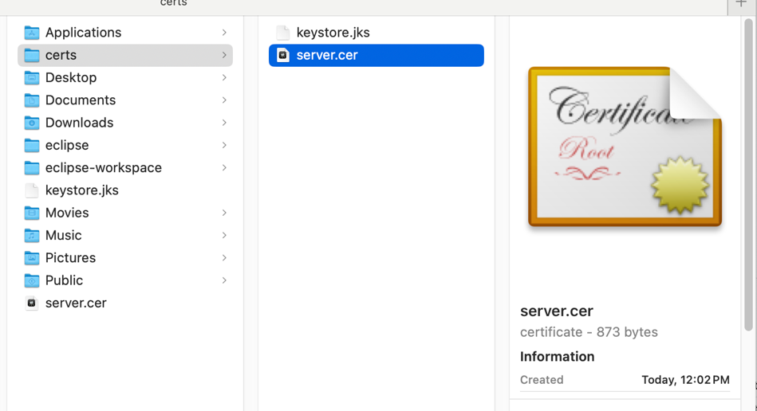Insert a screenshot below of the CER file.

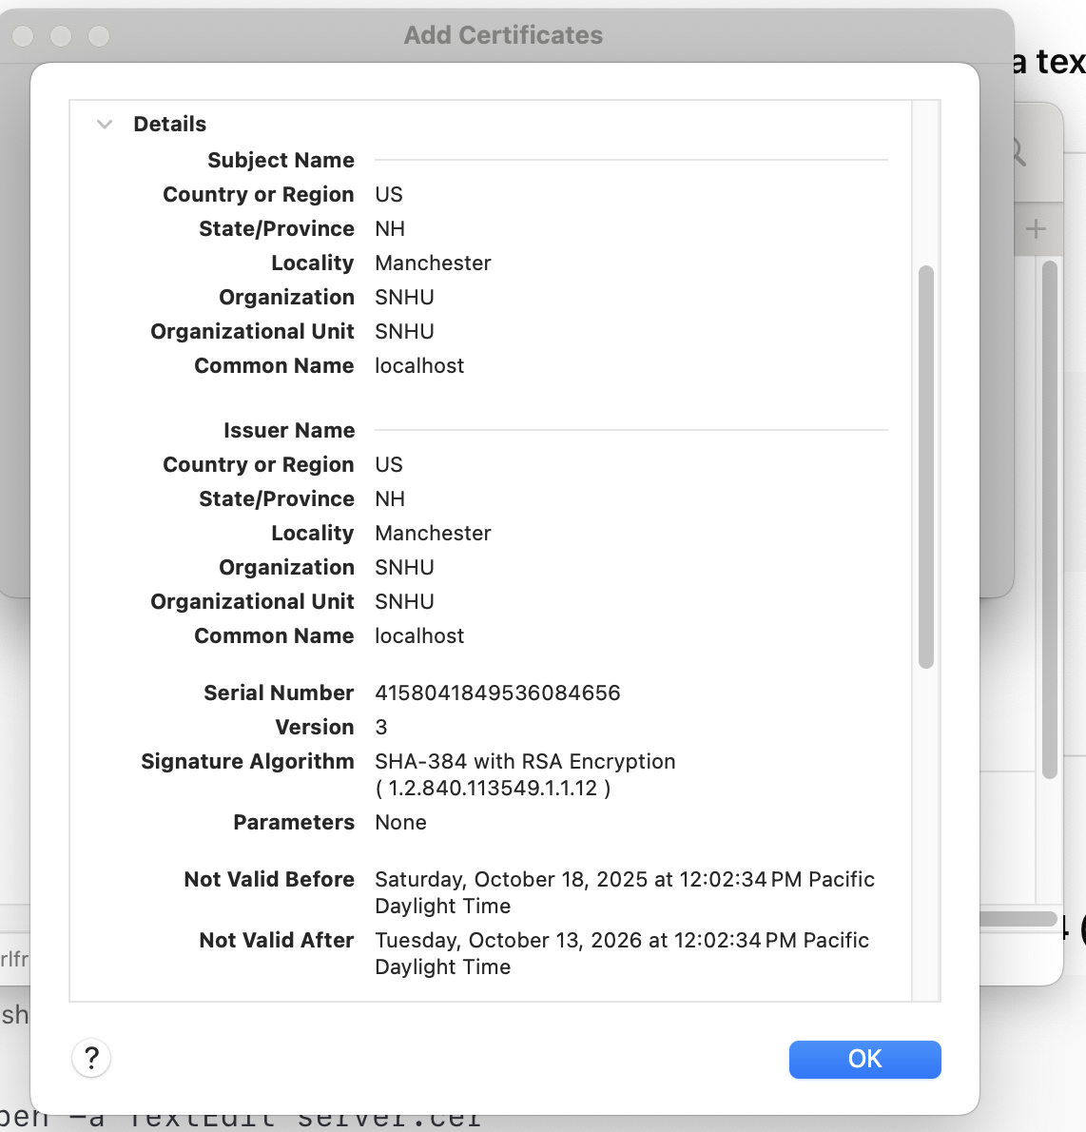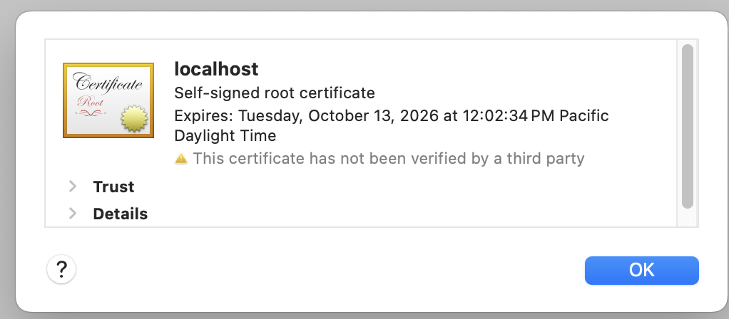

Steps to generate certificate

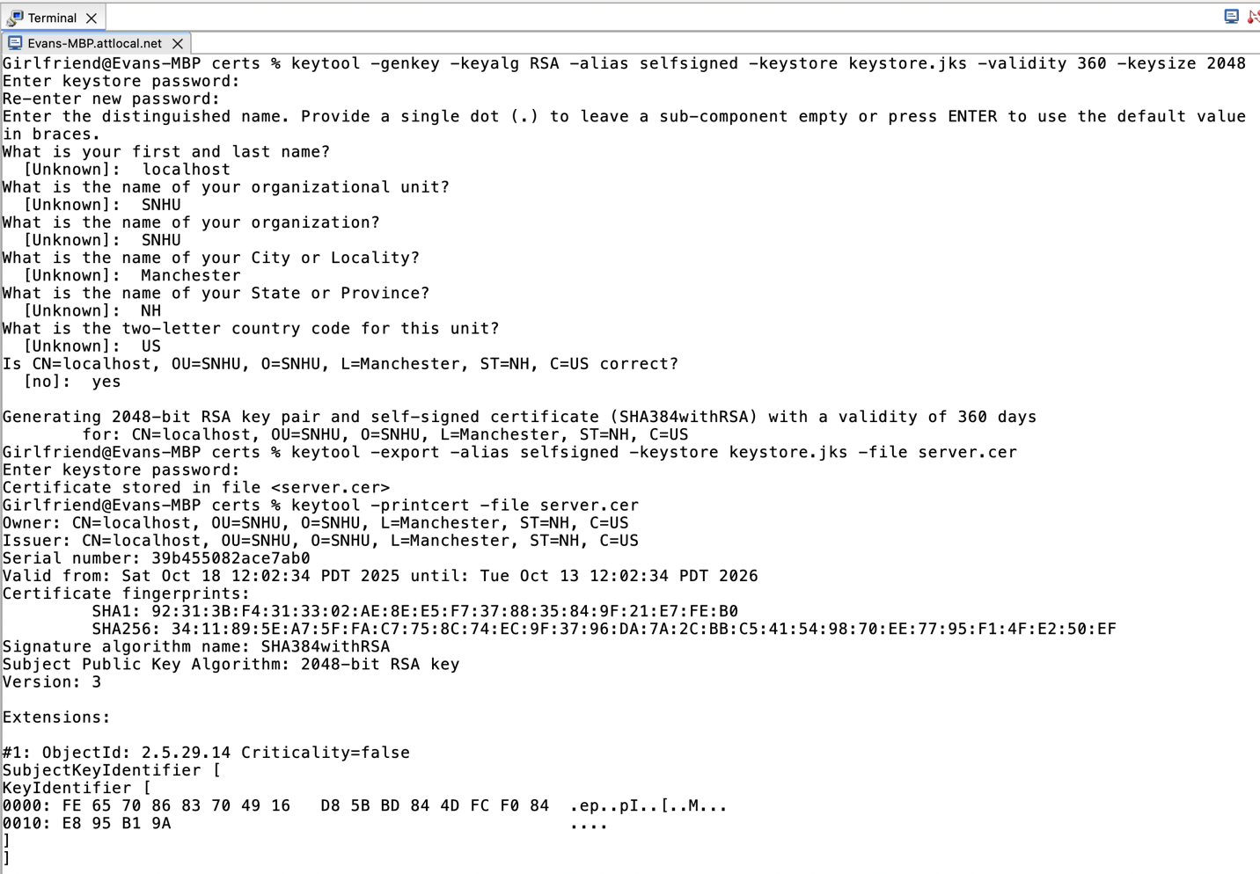

## Deploy Cipher

Insert a screenshot below of the checksum verification.

Step 1 update code in SslServerApplication.java

Setp 2 run the application

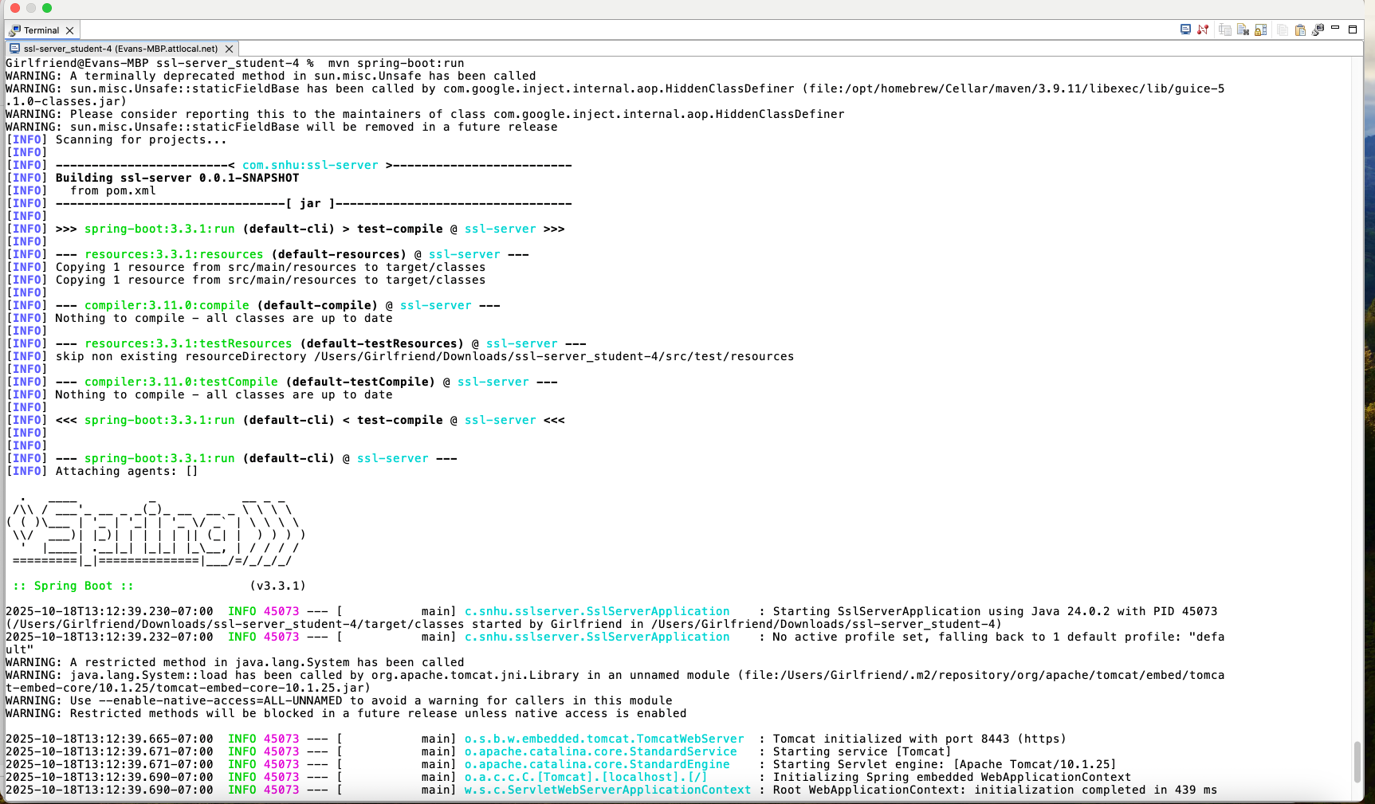

Successful run

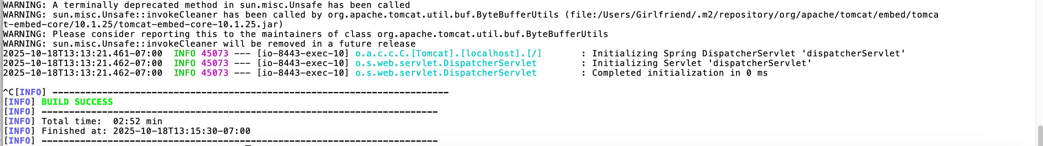

Checksum verification :

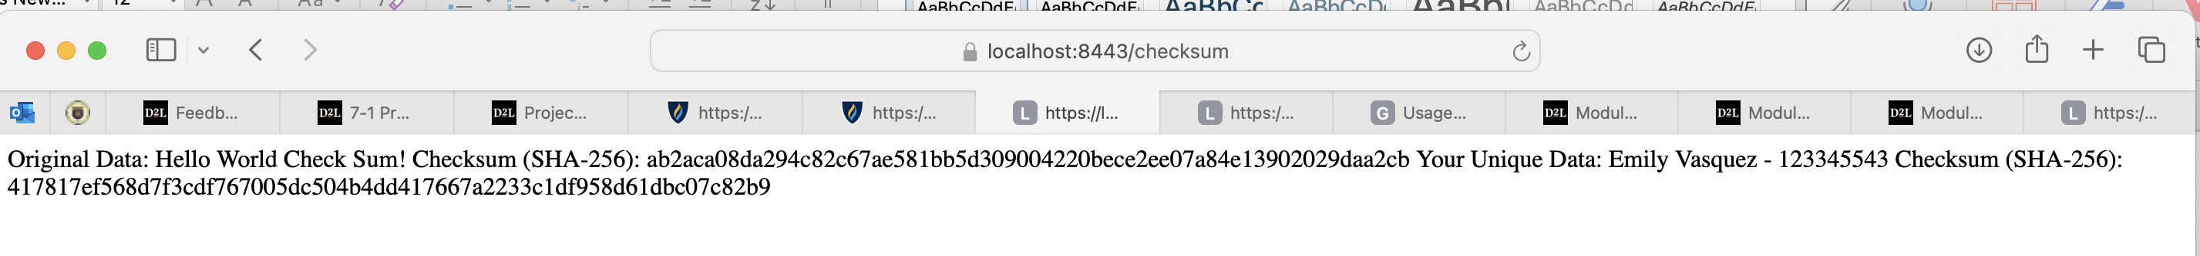

## Secure Communications

Terminal check.

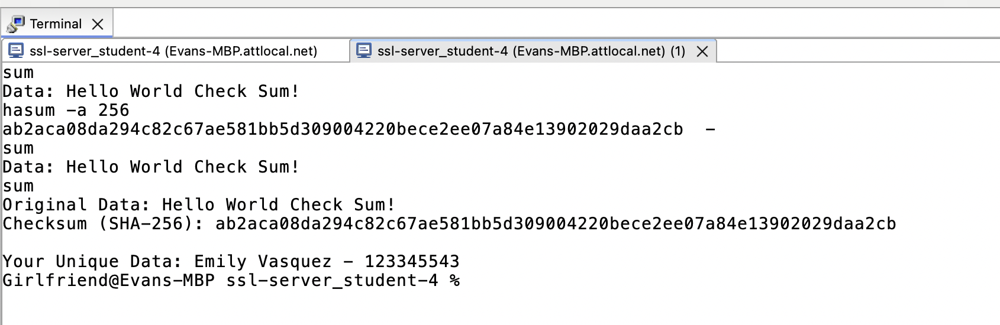

Insert a screenshot below of the web browser that shows a secure webpage.



## Secondary Testing

Insert screenshots below of the refactored code executed without errors and the dependency-check report.

SslServerApplication.java

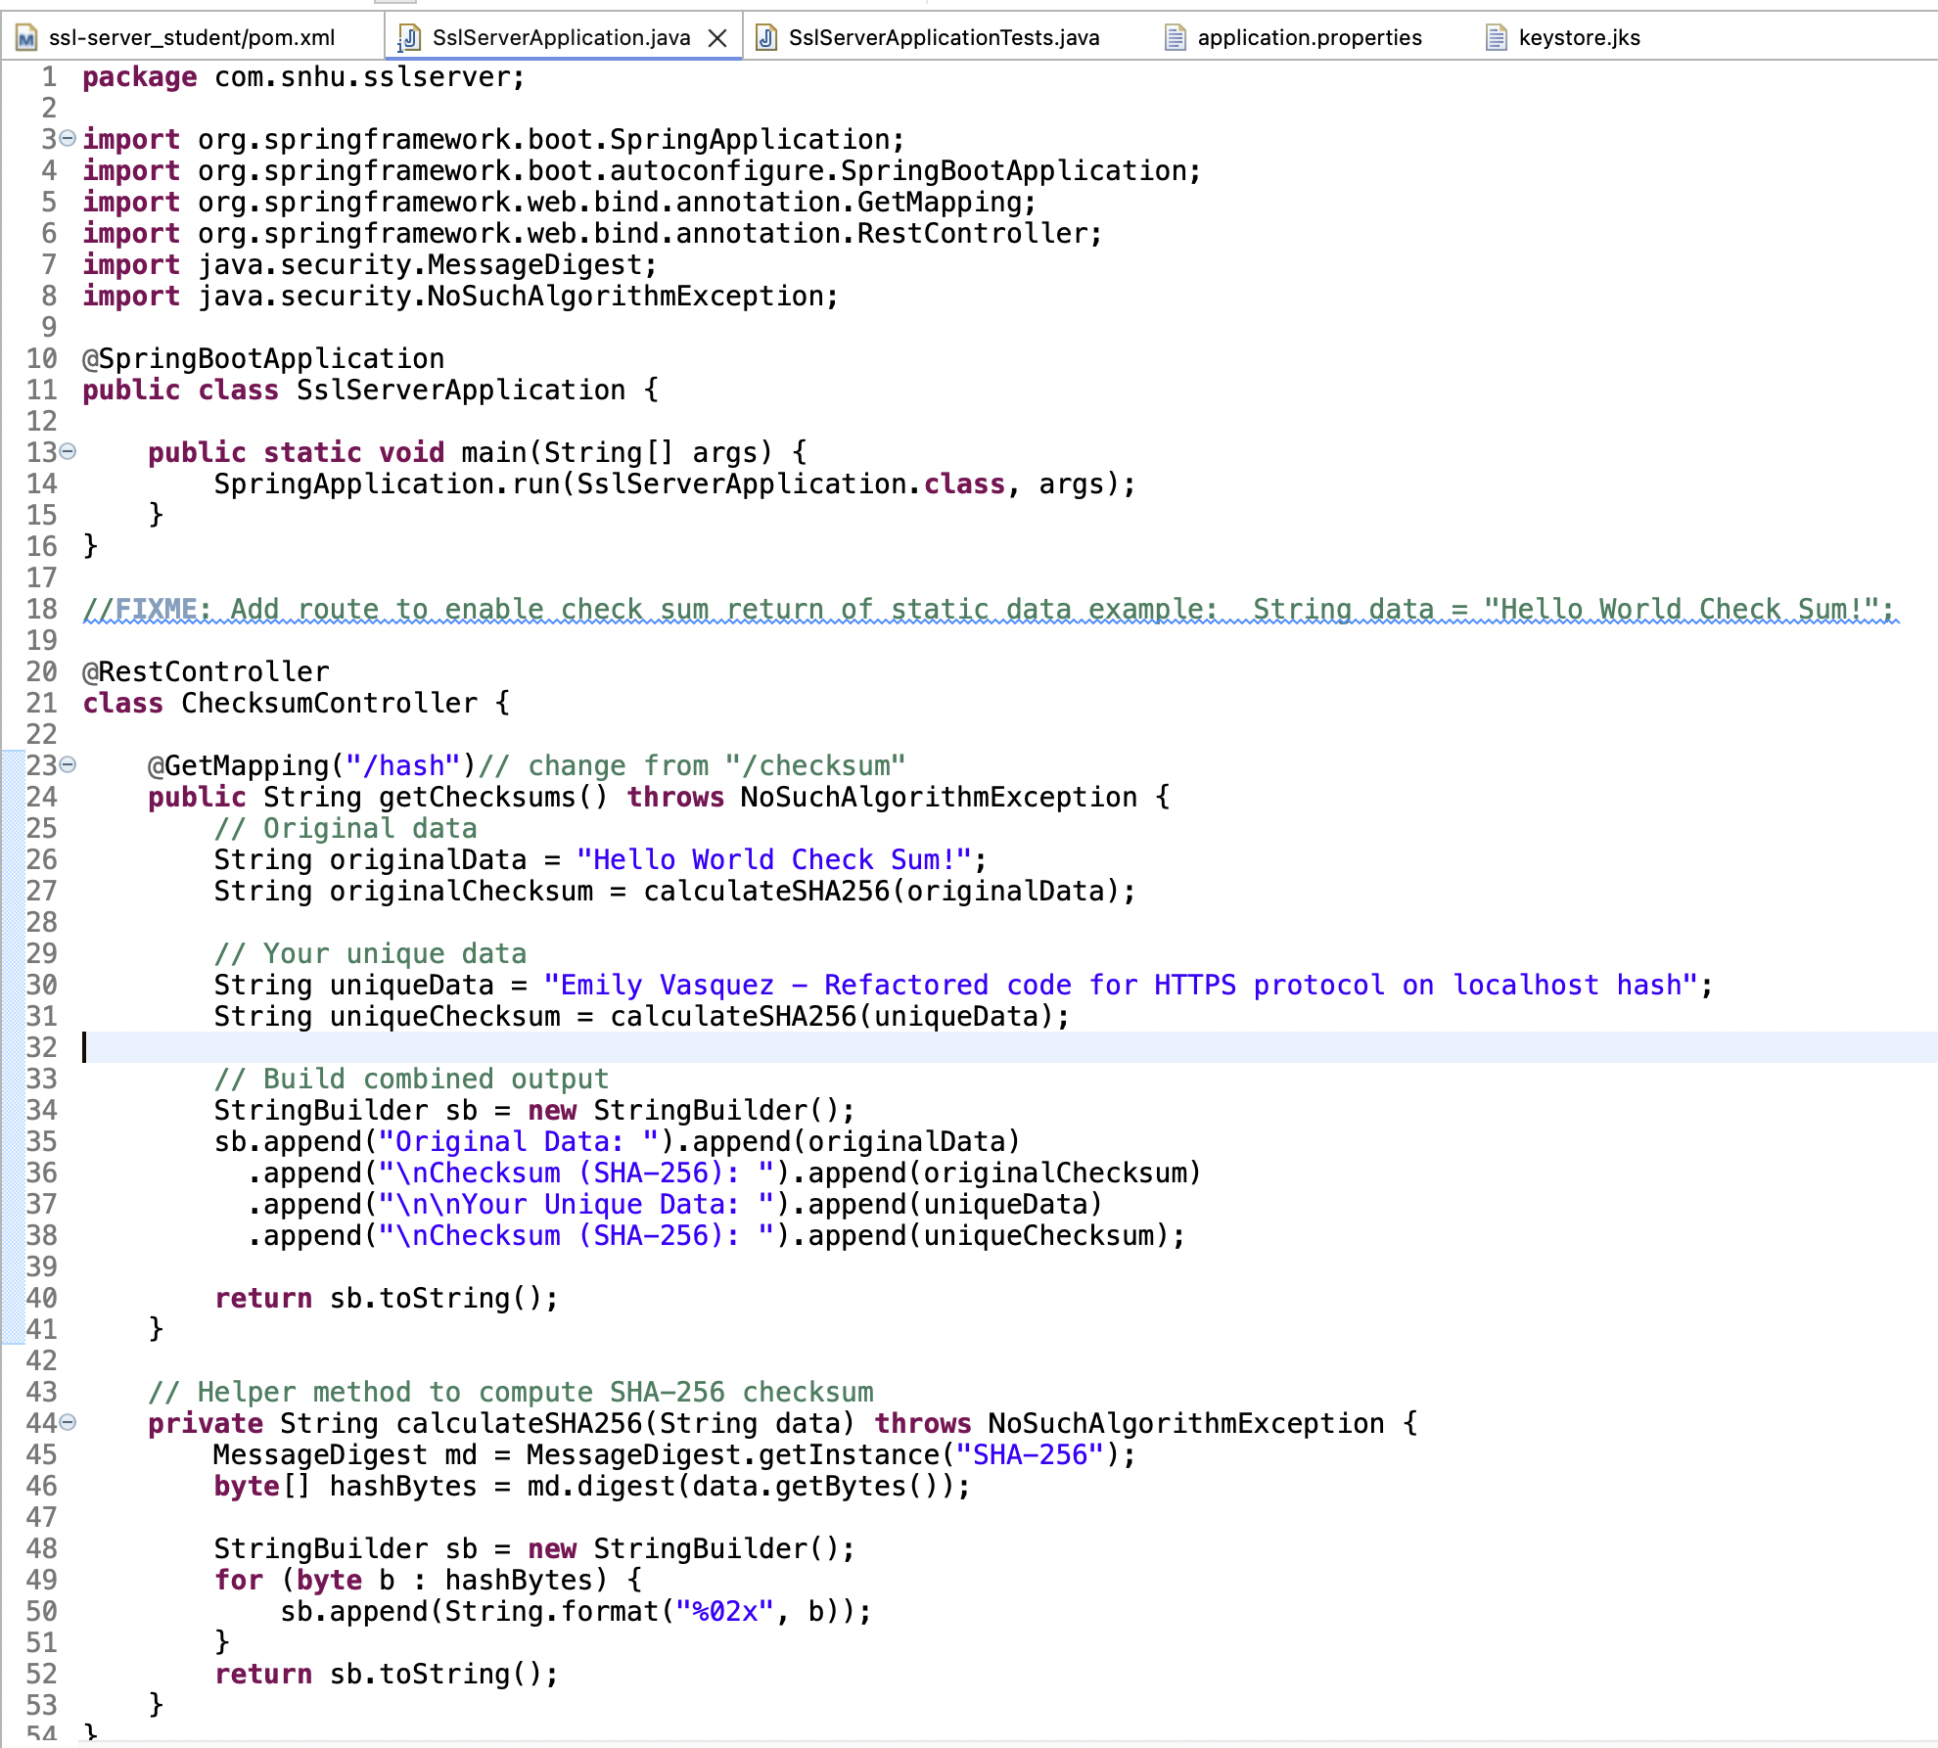

Added certificate

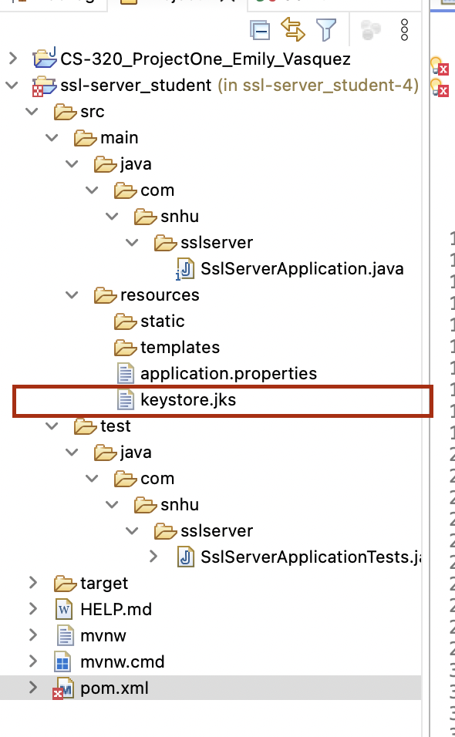

Updated application properties

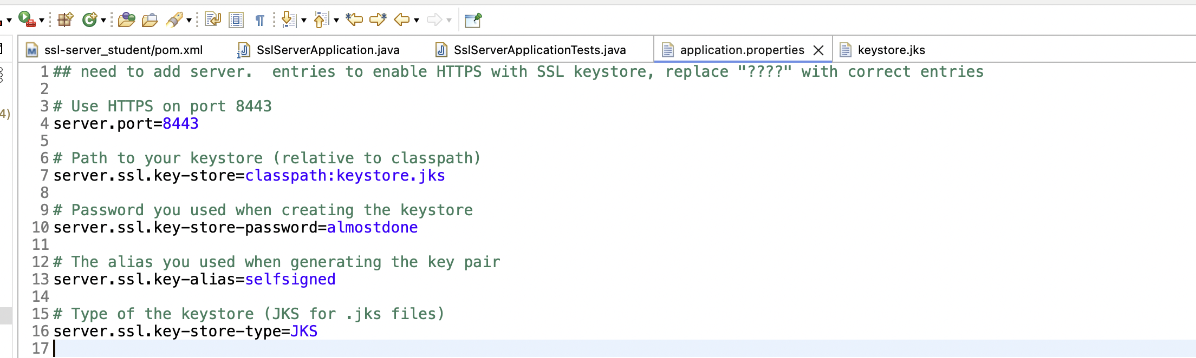

POM file improvements

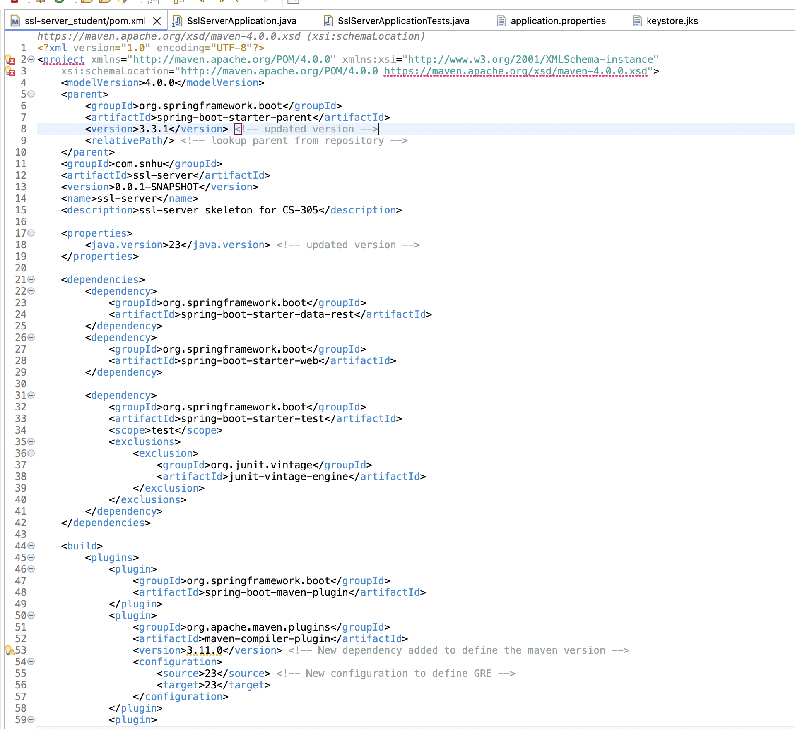

**Dependency Report**

file:///Users/Girlfriend/Downloads/ssl-server_student-4/target/dependency-check-report.htmlz

[Insert screenshots here.]

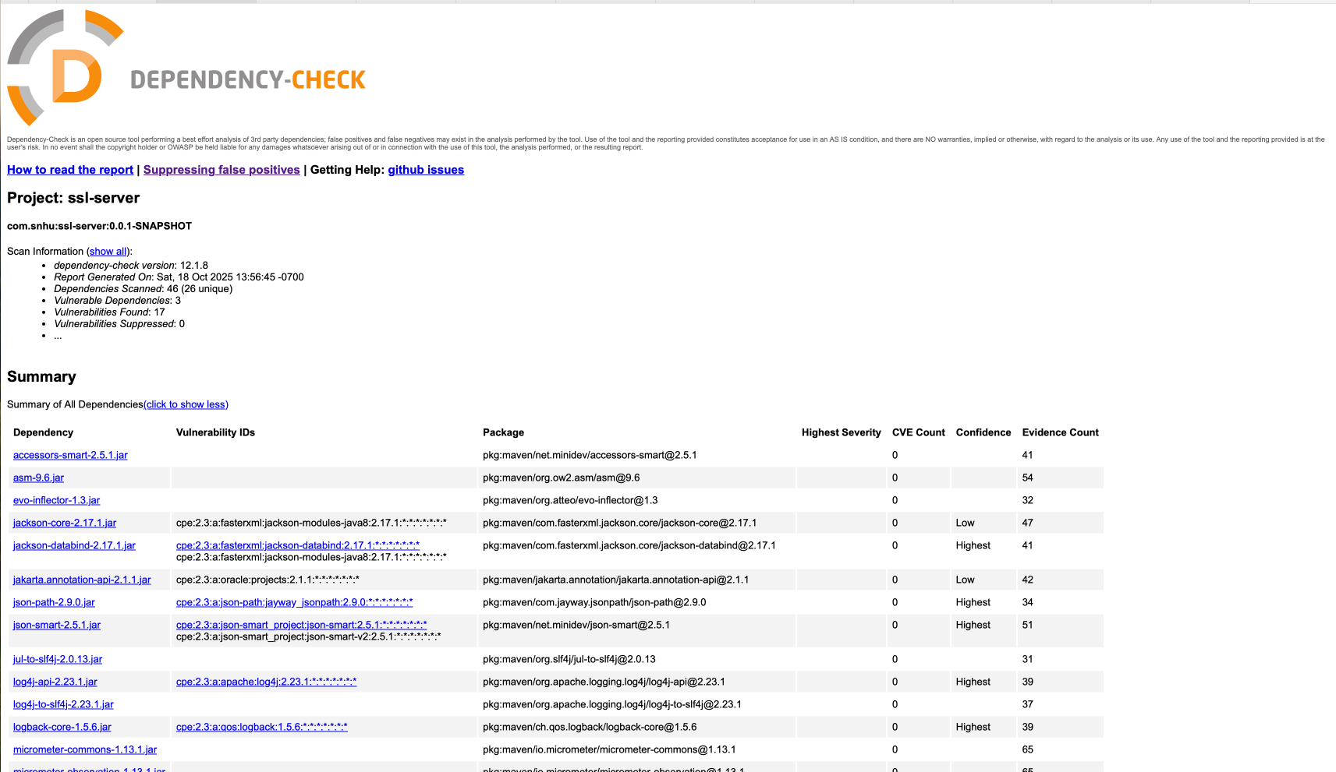

## Functional Testing

Insert a screenshot below of the refactored code executed without errors.

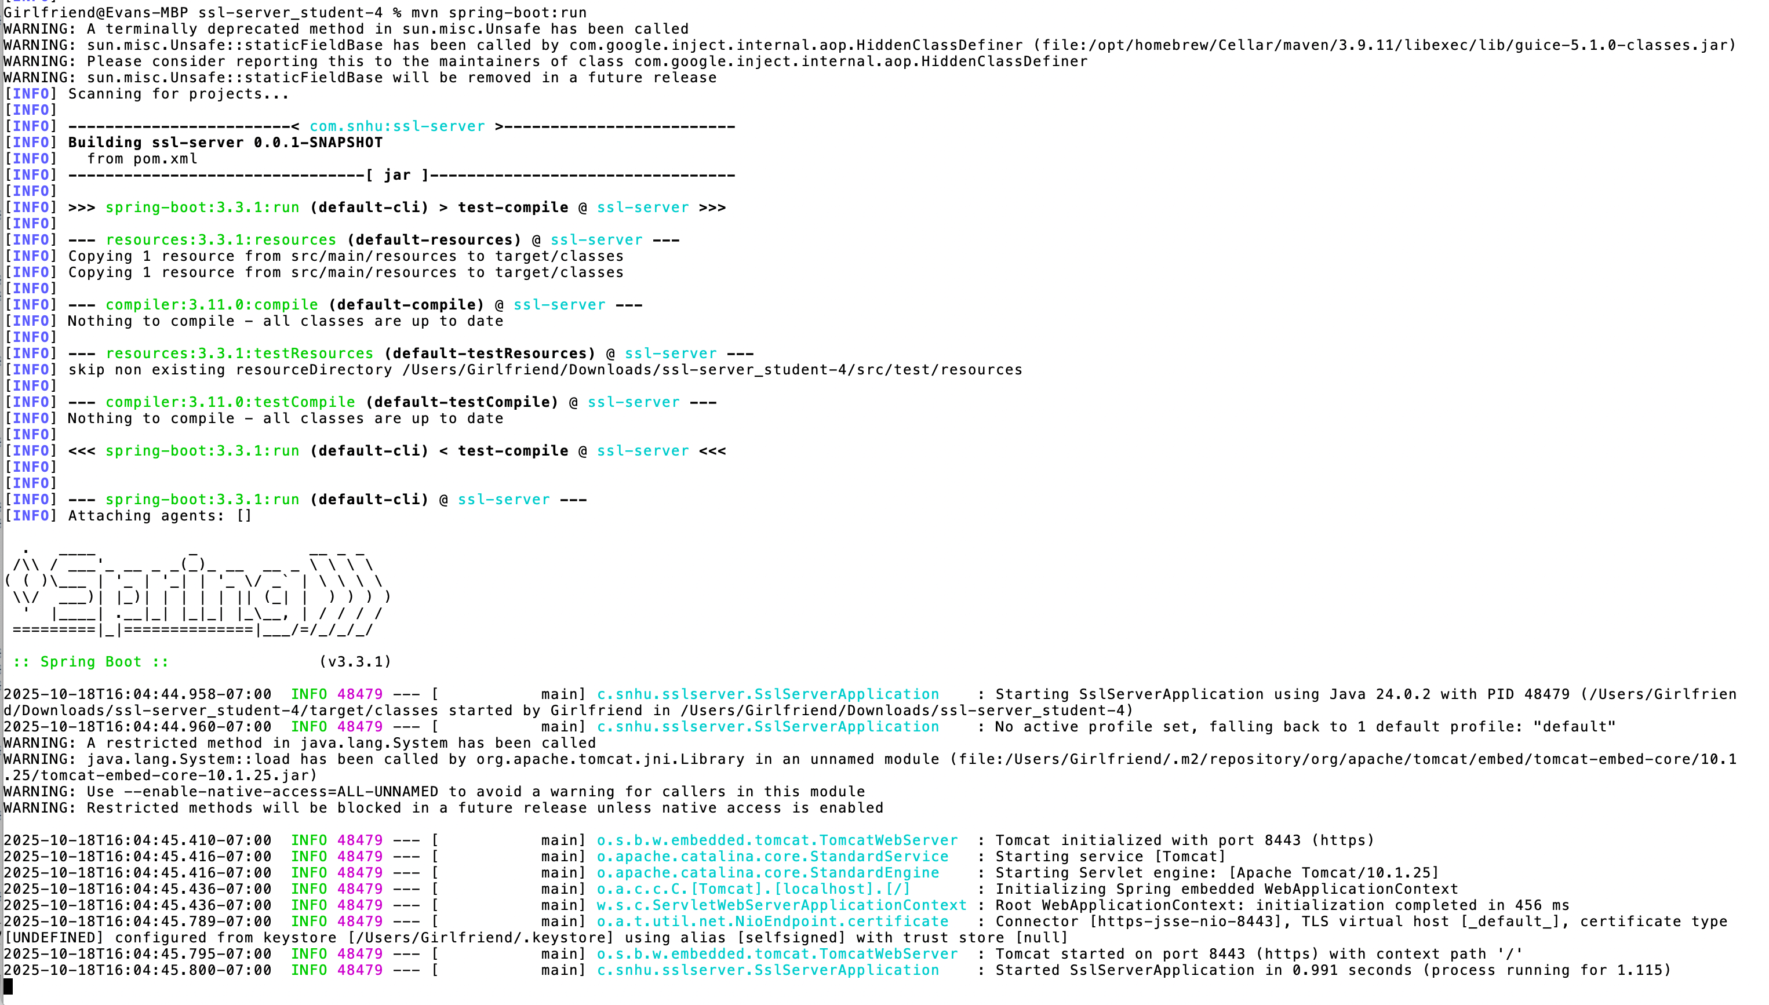

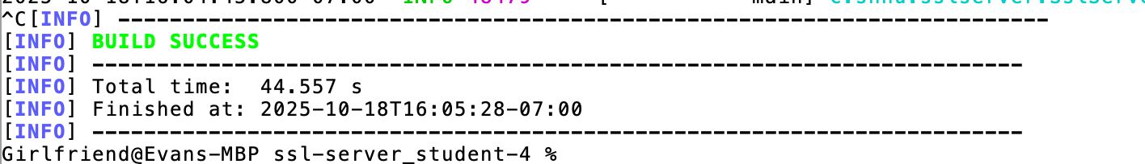

## 

## Summary

For this project, I refactored the code to make it both functional and secure. I kept the original data, "Hello World Check Sum!", to maintain the basic functionality, and I added a unique string with my name, "Emily Vasquez - Refactored code for HTTPS protocol on localhost hash", to show dynamic checksum generation. I implemented SHA-256 hashing to make sure both the original and unique data are protected and cannot be tampered with. I also updated the REST controller endpoint from "/checksum" to "/hash" and configured the application to use HTTPS with an SSL keystore, which makes the communication between the server and client secure. On top of that, I added the OWASP Dependency-Check plugin in the pom file to run static analysis on our dependencies and make sure no known vulnerabilities were introduced. The main areas I focused on were data integrity by using cryptographic hashing, secure transport by enabling HTTPS, and dependency security by running the static tests. I also reviewed the code manually to make sure there were no errors and that exception handling was correct. Overall, the refactored code keeps the original functionality, adds layers of security, and passes both the static and manual security checks.

## Industry Standard Best Practices

I applied industry standard best practices for secure coding to make sure the application stays safe and reliable. For example, I used HTTPS with an SSL keystore to protect data during communication, which is a widely accepted method to prevent eavesdropping or man-in-the-middle attacks. I also implemented SHA-256 cryptographic hashing for both the original and unique data, ensuring that sensitive information cannot be tampered with or altered. On top of that, I ran OWASP Dependency-Check to scan for known vulnerabilities in the project’s dependencies, following the best practice of verifying third-party code before using it. These practices help maintain the existing security of the application while adding extra layers of protection. Applying industry standard secure coding practices is valuable for the company because it reduces the risk of data breaches, protects user trust, and ensures compliance with security guidelines. By following these standards, the company can prevent potential financial losses and reputation damage while keeping the software reliable and secure.

**References**

Microsoft. (2025). Secure coding guidelines. <https://learn.microsoft.com/en-us/security/develop/secure-coding-guidelines>

National Institute of Standards and Technology. (2023). Secure Software Development Framework (SSDF). <https://csrc.nist.gov/projects/ssdf>

Oracle. (2025). Java Platform, Standard Edition 24 documentation. <https://docs.oracle.com/en/java/javase/24/>

OWASP Foundation. (2025). OWASP Dependency-Check. [https://owasp.org/www-project-dependency-check/](https://owasp.org/www-project-dependency-check/?utm_source=chatgpt.com)

OWASP Foundation. (2025). Top 10 security risks. <https://owasp.org/Top10/>

Southern New Hampshire University. (2025). CS 305 Integrating the Maven Dependency-Check Plug-in Tutorial. <https://learn.snhu.edu/content/enforced/2019664-CS-305-10343.202581-1/course_documents/CS%20305%20Integrating%20the%20Maven%20Dependency-Check%20Plug-in%20Tutorial.pdf?_&d2lSessionVal=ScQoRYLN9OTGv4T9RbCyYwie6&ou=1332052&ou=2019664>

Southern New Hampshire University. (2025). CS 305 Vulnerability Assessment Process Flow Diagram. <https://learn.snhu.edu/content/enforced/2019664-CS-305-10343.202581-1/course_documents/CS%20305%20Vulnerability%20Assessment%20Process%20Flow%20Diagram.pdf?_&d2lSessionVal=ScQoRYLN9OTGv4T9RbCyYwie6&ou=1332052&ou=2019664>

Spring Boot. (2025). Spring Boot reference documentation. <https://docs.spring.io/spring-boot/docs/current/reference/html/>